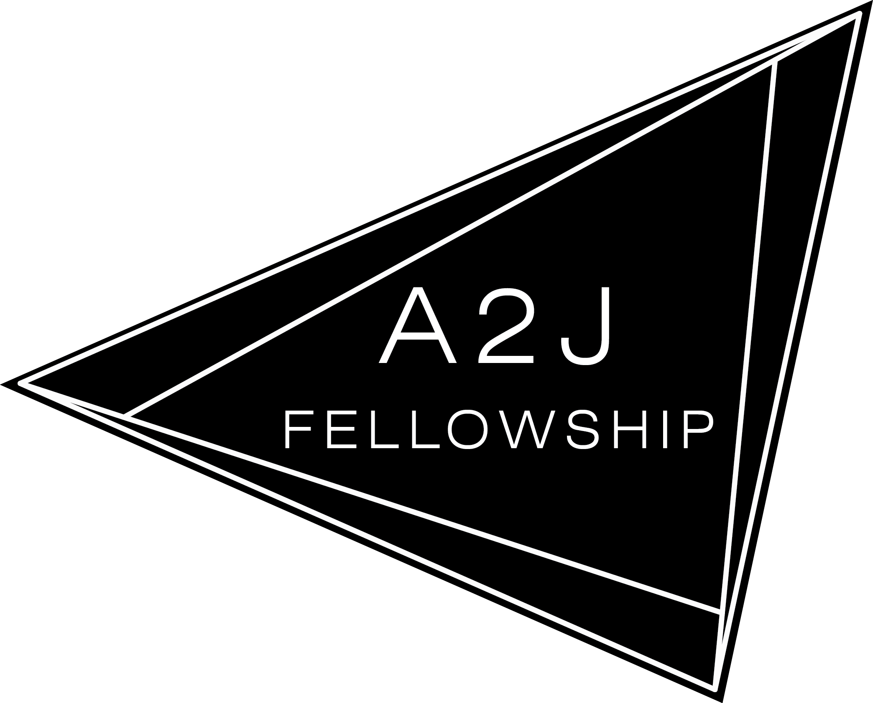
Access to Justice Fellowship
Fellow Application Form
For Fellowship period of September 2022 to June 2023

1) Personal information

Name | (English) | (Chinese)
Gender
Date of Birth (dd/mm/yy)
Email Address
Mobile No.
Nationality
Will you require a work permit to work in Hong Kong? | Yes / No | If yes, do you have a working permit to work here?  Yes/No
Languages | On the scale of 1 - 5 (1 = basic, 5 = fluent) indicate your fluency in:  - Written English:  - Spoken English:  - Written Chinese:  - Spoken Cantonese:  - Spoken Mandarin:  - Others (Please specify):
How did you hear about us? | - Social media (Please specify):  - Law School (Please specify):  - PILnet  - Innovator Farm / SIE:  - Law firm (Please specify):  - Others (Please specify):
2) Education, Employment and Volunteer experience

Please submit a CV that includes the following in reverse chronological order (i.e. most recent first): (i) qualifying law degree; (ii) other undergraduate or postgraduate degrees / diplomas / courses (if any); (iii) full-time employment or legal experience in the workplace or internship / employment with NGOs; and (iv) volunteer experience (if any).

Please provide supporting documents for qualifications stated in your CV, including but not limited to Academic Transcripts / Certificates / Letter from institutions.

Professional Examinations

Have you taken or do you plan to take the PCLL course? Full-time or part-time? | If yes, year of intended / actual completion:  Do not intend to pursue PCLL:
Please list the dates and details of your other professional qualifications (if any).

Please include the qualification, date and details.

Referee: Please provide the information of one referee, whom the A2J Fellowship may contact if necessary to better understand your application.

Title (Mr/Mrs/Ms/Miss/Dr)
Name of Referee
Relationship with the Applicant
Contact of the Referee (Telephone/Email)

3) A2J Fellowship Questions

1. Why are you interested in joining the Access to Justice Fellowship? Name 3 things that you would like to achieve from the Fellowship. (max. 450 words)

2. Please explain why you are interested in working with a labor-related NGO, and how you have demonstrated, through your legal studies, internships, extracurricular activities or otherwise, that you are suited to be placed there. (max. 300 words)
(Please see our website to learn more about which projects you would like to be involved in.)

3. What is your plan after the Fellowship, if any? If selected for the Fellowship, how does this 10-month experience fit in your career goals? (max. 450 words)

4. Identify an existing access to justice issue in Hong Kong and suggest a way to alleviate the situation. Please support your case with research. (max. 450 words)

5. Please describe the extracurricular activity and/or leadership role that is the most meaningful or impactful to you, explain why, and what you have learned from this experience. (max 450 words)

6. Please list any other skills/aptitudes/experiences (e.g. software skills) that you have (if applicable).

